Bivariate Data

 | Party A | Party B | Totals
Male | 215 | 104 | 319
Female | 42 | 61 | 103
Totals | 257 | 165 | 422

Row percentages

 | Party A | Party B | Totals
Male | 67% | 33% | 100%
Female | 41% | 59% | 100%

Column percentages

 | Party A | Party B
Male | 84% | 63%
Female | 16% | 37%
Total | 100% | 100%

Explanatory variable: the variable used to explain or predict a difference in the response variable
Response variable: also called the dependent variable

Scatterplots

Positive: from bottom left to top right
Negative: from top left to bottom right

Strong: how close the points follow a linear pattern

Eg: The graph above is a strong positive graph

Correlation coefficient/determination

R: measures the direction and strength of a linear relationship. Says that ‘X’ is a good predicter of ‘Y’

R^2: measures the percentage variation in both variable with respect to each other

Euler and planar graphs

$$v+f=e+2$$

If Euler’s rule works, then the graph can be drawn as planar

Planar: no edges in a graph cross over each other

Residuals

Refers to the vertical distance between a data point and line of best fit
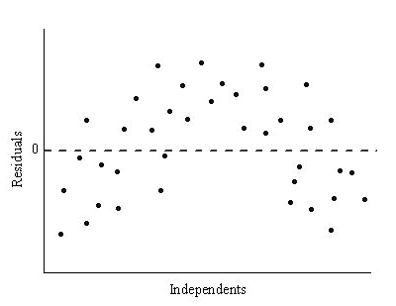

Linear model only appropriate if residuals are in random order

How to calculate

- Statistics
- Enter numbers
- Calc
- Regression
- Linear regression
- Copy residuals to list 3

Sequences

Arithmetic: each term is found by adding or subtracting/linear growth

Arithmetic sequeces
Explicit | $$T_{n}=a+\left(n-1\right)×d$$
Recursive | $$T_{n+1}=T_{n}+d, T_{1}=a$$

Where;
A: the first term in the sequence
N: the ‘nth’ term in the sequence
D: the common difference

Examples

$$Recursive, T_{n+1}=T_{n}+5, where T_{1}=10$$
OR

$$Explicit,T_{n}=10(n-1)×5$$

Geometric: each term is found by multiplying or dividing/exponential growth

Geometric sequences
Explicit | $$T_{n}=ar^{n-1}$$
Recursive | $$T_{n+1}=T_{n}×r,T_{1}=a$$

Where;
r: the common ratio
A: the first term
N: the ‘nth’ term in the sequence

Examples

$$Recursive, T_{n+1}=T_{n}×4, where T_{1}=5$$

OR

$${Explicit, T}_{n}={(5)(4)}^{n-1}$$

Types of graphs

Simple graph: does not contain loops or multiple edges

Connected graph: a possible path between every vertex

Directed graph: the is directed by the use of arrows

Weighted graph: edges on a graph that have been assigned a numerical value

Tree: connected graph that doesn’t contain any cycles or multiple edges

Bipartite: has 2 sets of vertices/2 groups

Network terminology

Loop: an edge joining a vertex to itself

Multiple edges: 2 or more edges that have the same start and end vertices

Bridge: an edge that connects 2 parts of a graph that would otherwise result in an isolated vertex

Degree of a vertex: number of edges connected to a vertex

Open walk: starting and ending vertices are different

Closed walk: starting and ending vertices are the same, without the end and start vertices being connected

Open path: starts in one place and finishes in another. Can’t repeat vertices or edges

Closed path (cycle): visits every vertex and end at the starting vertex (the last vertex is joined to the first vertex). Can’t repeat vertices or edges

Open trail: a walk with no repeated edges and starts and finishes at different vertices. May repeat vertices but not edges

Closed trail (circuit): a walk with no repeated edges that starts and ends at the same vertex. May repeat vertices but not edges

Eulerian graphs

Eulerian graph: contains a circuit/closed trail that visits all edges in the graph once only and may repeat vertices

Is Eulerian if all the degrees of the vertices are even
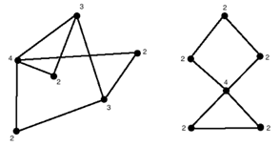

Semi Eulerian graph: contains an open trail that visits all edges in the graph once only and may repeat vertices

Is semi-Eulerian if only 2 vertices have an odd degree
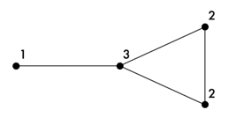

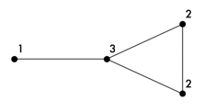

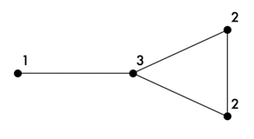

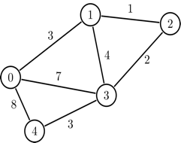

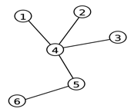

Interest

Simple interest

$$p×r×t$$

Where;

P: principle
R: rate as a decimal
T: time in years

Compound interest

$$p{(1+\frac{r}{n})}^{nt}$$
Where;

P: principle
R: rate as a decimal
N: number of times compounded in a year
T: time in years

Effective interest rate
$${\left(1+\frac{i}{n}\right)}^{n}-1$$

Where;

I: amount of interest per annum
N: number of compounding

Hamiltonian graphs

Hamiltonian graph: contains a closed path/cycle that visits all vertices in the graph once only (except start and end vertex) and does not have to pass through all edges

Visits all vertices once except for start and end
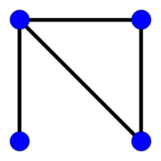
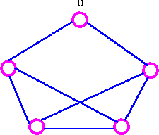

Semi-Hamiltonian: contains an open path that visits all vertices in the graph once only and does not have to pass through all edges

Must repeat a vertex in order to visit them all

Financial calculator

Jackson borrows $20,000 at 12% p.a. compounding monthly. He pays $350 every month to pay off the loan. How much would he still owe after 5 years of payments?
Type | Loan | PMT | -350
N | $$5×12$$ | FV | -$7749.55
I% | 12 | P/Y | 12
PV | 20000 | C/Y | 12

N: time in years × number of compounding periods annually
I: interest rate
PV: present value
PMT: amount paid each period
FV: future value
P/Y: payments per year
C/Y: compounding per year

Lily invests $10,000 at 7% p.a. compounding half-yearly. Lily wants her account to reach $50,000 in 10 years. How much does she need to deposit every six months to reach this goal?

Type | Investment | PMT | -$1064.44
N | 10×2 | FV | 50000
I% | 7 | P/Y | 2
PV | 10000 | C/Y | 2

Grace invests $700,000 to buy an annuity that pays $50,000 at 5.4% p.a. compounding annually. How many years will Grace be able to withdraw money for?

Type | Annuity | PMT | 50000
N | 26.82 | FV | 0
I% | 5.4 | P/Y | 1
PV | 700000 | C/Y | 1
Analysing loans
Calculating final payment

$$Final=r+T_{FN}$$

R: regular payment amount
$T_{FN}$: first negative value that appears

Total cost of a loan

$$\left(n×r\right)+final$$

N: number of full payments
R: regular payment amount
F: final payment amount

Depreciation

Flat rate

$$initial value×opposing decimal percentage$$

Eg, 10% = 0.9

$$T_{n+1}=T_{n}\left(0.9\right), where T_{1}= ?$$

Deseasonalising data

Yr/Pd | Period 1 | Period 2 | Period 3
Year 1 | 411 | 648 | 699
Year 2 | 532 | 632 | 741

- Average the rows

Year 1 | (411+648+699)/3  =586
Year 2 | (532+632+741)/3  =635

- Divide averages into original values

Yr/Pd | Period 1 | Period 2 | Period 3
Year 1 | 411/586  =0.7014 | 648/586  =1.1058 | 699/586  =1.1928
Year 2 | 532/635  =0.8378 | 632/635  =0.9953 | 741/635  =1.1669

- Average the columns with the answers derived from the division in step 2/seasonal index

Average period 1 | (0.7014+0.8378)/2  =0.7696
Average period 2 | (1.1058+0.9953)/2  =1.0505
Average period 3 | (1.1928+1.1669)/2  =1.1799

- Deseasonalise data by dividing the original values into the answers derived from step 3

Yr/Pd | Period 1 | Period 2 | Period 3
Year 1 | 411/0.7696  =534.04 | 648/1.0505  =616.85 | 699/1.1799  =592.42
Year 2 | 532/0.7696  =691.27 | 632/1.0505  =601.62 | 741/1.1799  =628.02

Seasonal index

From example above

Average period 1 | (0.7014+0.8378)/2  =0.7696
Average period 2 | (1.1058+0.9953)/2  =1.0505
Average period 3 | (1.1928+1.1669)/2  =1.1799

If there is 3 periods then the seasonal index has to equal 300% or 3. Eg, 0.7696+1.0505+1.799 = 3 or 300%

Perpetuities

$$priciple=principle×rate-withdrawral$$

Substitute x into principle rate or withdrawal to find answer

Annuities

$$T_{n+1}=T_{n}×rate-withdrawral×{wi}^{n-1}$$

WI: percentage increase of withdrawal, eg 1.02 for 2%
Bolded: only happens if withdrawal increases each period

Adjacency matrices
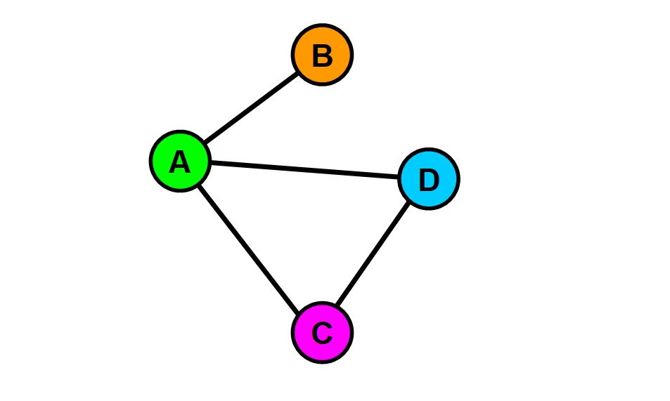

A
B
C
D
C
B
A
$$\begin{matrix}0 & 1 & 1 & 1 \\ 1 & 0 & 0 & 0 \\ 1 & 0 & 0 & 1 \\ 1 & 0 & 1 & 0\end{matrix}$$
D

Moving averages

Odd moving averages

Period | Value | 3-PMA
1 | 15
2 | 16 | 17
3 | 20 | 17.67
4 | 17 | 18.33
5 | 18

Even moving averages

Period | Value | 4-PMA | 4-PCMA
1 | 23
1.5
2 | 22
2.5 |  | 20
3 | 18 |  | 19.5
3.5 |  | 19
4 | 17
4.5
5 | 19

Minimum spanning trees
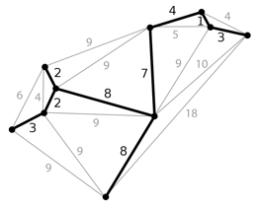

Reach every vertex in the fewest amount of time

Prim’s algorithm

 | A | B | C
A | 230 | 210 | 340
B | 230 | 180 | 215
C | 210 | 200 | 185

- Choose a vertex, say A
- Cross row A out since A can’t go to A
- Choose the smallest number in column A, 210
- Cross row C out since you’ve just picked it
- Start at the top of column C and do it again

Maximum flow
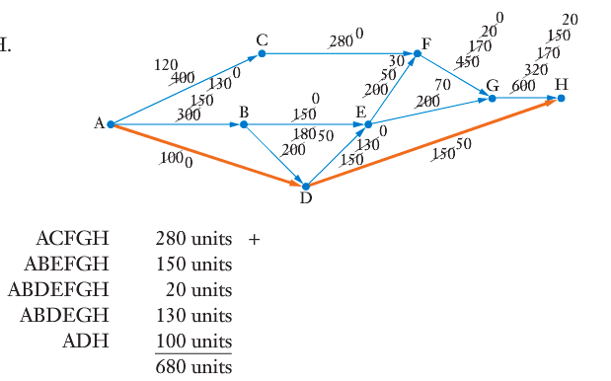

Minimum cut: cut can be made on the graph which equals the maximum flow

Project networks

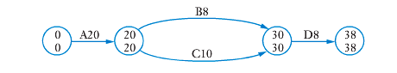
Minimum completion time: how quick can all the jobs be done
Critical path: the path that equals the minimum completion time
Earliest start time: how early can a task start, eg D = 28
Latest start time: how late a task can start, eg D= 30
Float time: how long a task has to spare before it has to start, eg B has a float time of 2

Hungarian algorithm

- Construct a cost matrix
- Take the largest number away from every number in the matrix = only for maximum
- Subtract the smallest number in each row from every number in that row
- Subtract the smallest number in each column from every entry in that column
- Draw as few vertical and horizontal lines as possible. If the number of lines matches with rows/column then your fine
- If not, take the smallest number away that hasn’t been lined out from all the other numbers who haven’t been lined out

No. people ≠ number of tasks

- Add a row or column of 0’s to make it even
- Subtract the smallest number in each row or column which changes the matrix from every number in that row/column
- Draw vertical and horizontal lines
- Where 0’s cross over, add the number you took away in the row or column takeaways and takeaway smallest number that isn’t crossed out from all the other numbers
- Draw lines and repeat until the amount of lines matches the rows or columns

Other

Extrapolation: estimating a value outside the original data given by assuming that existing trends present will continue
Interpolation: estimation of a value which is within the limits of the data set

